Brokerage App Review Hargreaves Lansdown

App Metadata
APP NAME: Hargreaves Lansdown
Region / Pair: UK – Trading212 vs Hargreaves Lansdown
Reviewer: Victoria Hyde
Date: 07/01/2025

1. Company Background (Phase A)
1.1 Basic Details
Year founded: 1981 (specifically 1 July 1981)
Founders: Peter Hargreaves and Stephen Lansdown
Headquarters (city, country): Bristol, England, United Kingdom
Corporate structure (public/private/subsidiary/etc.): Formerly publicly listed as Hargreaves Lansdown plc on the London Stock Exchange; as of 2025 the business has been taken private by a consortium.
1.2 Funding & Investors
Key funding rounds (year + amount): Publicly listed in 2007. The relevant major transaction: in August 2024 the board agreed a takeover valuing the company at ~ £5.4 billion by private equity bidders.
Lead investors: In the takeover, the acquiring consortium includes CVC Capital Partners, Nordic Capital and a subsidiary of the Abu Dhabi Investment Authority.
Latest known valuation: ~ £5.4 billion agreed takeover price (August 2024) for the business.
1.3 User Base & AUM
Total registered users: The business cites “over 2 million clients” in the UK as part of its “over £172 bn by over 2 million clients”.
Active users (if known): Specific monthly/daily actives not publicly disclosed.
AUM: As of 30 June 2024, figures:
- £60 billion+ in ISA AUA
- £34 billion+ in Fund & Share Account AUA
- £49 billion+ in SIPP AUA
Additionally: At 19 July 2024, HL hit £155.3 billion assets under administration.
Revenue / profitability (if available): For year ended 2024: revenue ~ £764.9 million and net income ~ £293.2 million according to aggregated data.
Notable metrics (e.g. transaction or growth stats): Net new business flows of £4.2 billion in the year ended June 2024.
The company is reported to be the “UK’s No.1 Direct-to-Client Platform for number of clients and assets” for Q1 2025.
1.4 Geographic Reach & Regulation
Primary target markets (countries/regions): United Kingdom (domestic UK retail investors) primarily. (No major international footprint dominating as of public data).
Licenses / regulators: Operates under UK regulation via the Financial Conduct Authority (FCA). Hargreaves Lansdown is authorised and regulated by the FCA.

Regulatory events / controversies:
- https://www.telegraph.co.uk/money/investing/stocks-shares/hargreaves-lansdown-hit-tech-glitch-amid-market-turmoil/
- The company was involved in the fallout from the collapsed fund of Neil Woodford (Woodford Equity Income Fund) which was heavily recommended via HL’s “Wealth 50” list; this caused reputational damage.
- There are reports of the company’s technology infrastructure being under pressure (outages during high volume periods) and regulatory scrutiny from the FCA around cash interest paid on clients’ accounts.
1.5 Mission & USP
Mission (paraphrased): To support private investors by helping them save and invest for a better future, giving them access to tools, information and service that allow them to take control of their financial lives.
USP (what they claim makes them different):
A comprehensive investment platform for UK private investors combining funds, shares, ISAs, SIPPs, savings — all in one place.
High-service premium offering: emphasises strong research, user support, broad investment choice and brand trust.
Recognised as the UK’s leading investor platform (“UK’s No.1 platform for private investors”).

2. Onboarding & First Impressions (Phase A – 2.2)
2.1 Download & Installation
Device & OS used: iPhone 14 Pro, 26.1
App version: 2025.46.0
File size (approx): 556.1 MB
Permissions requested (tick):
- Camera [ ]
- Microphone [ ]
- Location [ ]
- Notifications [/]
- Tracking/Ad ID [/]
- Other: __________
Risk warnings shown on first launch? [/] Yes [ ] No
2.2 Account Creation & KYC
Time to complete onboarding (mins): 10-20 mins
Number of screens / steps: 12-18 steps
When you’re opening an account it explains that before opening an account you need to be:
- Comfortable building and maintaining your own portfolio
- Confident making long-term investment decisions
- Free from significant debt
- Clear on their charges and how you’ll be affected by tax
What you need to know:
- Investments can go up and down in value
- To open an HL Fund Account
What you need to have in hand:
- Personal details (name, DOB, address history)
- National Insurance number (UK)
- Bank account details
- ID (passport or driving licence)
Steps:
- Intro/eligibility disclaimer
- Account type selection
- Risk / responsibility statements
- Personal details (name, DOB)
- Address history
- Contact details
- Tax residency / NI number
- Investment knowledge / experience
- Bank details
- Declarations & confirmations
- ID verification (document capture)
- Selfie / liveness check
- Review summary screen
- Submission confirmation
Clarity of language (1–5): 3 - clear but quite dense and compliance-heavy
Visual clarity (1–5): 3 - functional but dated; text-heavy with limited visual hierarchy
Progress indicator present? [/] Yes [ ] No
Can switch language during onboarding? [ ] Yes [/] No
KYC documents requested (tick):
[/] ID [/ ] Proof of address [ ] Tax ID [/] Selfie/Liveness [ ] Other:
Upload method (tick): [/] Photo scan in app [/] File upload [ ] Manual entry
Notes: Opening an account isn’t done within the app - takes you to google chrome and the company webpage hl.co.uk (not integrated).
Overwhelming number of accounts that you can open:
- HL Stocks and Shares ISA
- HL Fund and Share Account
- HL Self-Invested Personal Pensions (SIPP)
- HL Active Savings Account
- HL Cash ISA
- HL Lifetime ISA
- HL Junior ISA
- HL Self-Invested Personal Pension (SIPP)
- HL Bare Trust
2.3 Funding & Deposits
Available funding methods (tick): [/] Bank transfer [/] Debit/Credit card [] E-wallet(s): Apple Pay [ ] Instant local rails [ ] Crypto deposit
Minimum deposit: £1
FX fees clearly disclosed? [/] Yes [ ] No
Promised funding time:
- Debit card / Apple Pay: Instant
- Bank Transfer: Same day to 1-2 working days
Observed:
- Card payments generally instant
- Bank transfers often next working day, sometimes slower depending on bank cut-off
Friction / confusion notes:
- Funding options are functional but not modern — no real-time bank rails (e.g. open banking instant pay-ins).
- FX fees lack visibility at the moment of action, which can catch users off guard when investing internationally.
- Distinction between depositing cash vs actually investing it is not always clear → funds can sit uninvested.
- Credit card support is unclear / inconsistently presented, creating ambiguity.
- Overall flow feels more “account top-up” than seamless investing journey compared to newer apps.
2.4 Welcome Screens & Narrative
Explains services? [/] Yes [ ] No
Explains fees? [/] Yes [ ] No
Explains risks? [/] Yes [ ] No
Beginner tips present? [ ] Yes [/] No
Gamified onboarding? [/] Yes [ ] No
Overall first impression (2–3 sentences): The onboarding experience is compliance-led, with a strong emphasis on risk warnings, responsibilities, and regulatory disclosures rather than user guidance. While services and fees are technically explained, the presentation is dense and assumes a level of financial literacy, offering little in the way of beginner-friendly support. Overall, it feels functional but dated, prioritising regulatory clarity over engagement or ease of entry.

3. Navigation & Information Architecture (Phase A – 2.3)
3.1 Menu Mapping
Bottom nav tabs:
- Portfolio
  - Overview
  - Watchlists
- Discover
  - Overview
  - Investing
  - Savings
  - Markets
  - Watchlists
  - News
- Markets
- Watchlists
- News
  - Grouped by Theme
Side/hamburger menu items:
- Personal details
- Messages
- Settings
- See what’s changed
- Help
- Contact us
- Send us feedback
3.2 Accessibility & Customisation
Dark mode: [/] Yes [ ] No
Font size controls: [ ] Yes [/] No
Language options: Can’t find it if there is the availability
Biometric login (Face/Touch ID): [/] Yes [ ] No
Notification preference granularity (1–5): 1 - literally just opt in or out for emails/phone calls/post
Accessibility features (screen readers, haptics, etc.): I don’t see accessibility settings
3.3 Persistent Navigation & Search
Navigation type: [/] Bottom bar [ ] Side drawer [ ] Floating buttons [ ] Hidden menus
Search test – Shell stock:
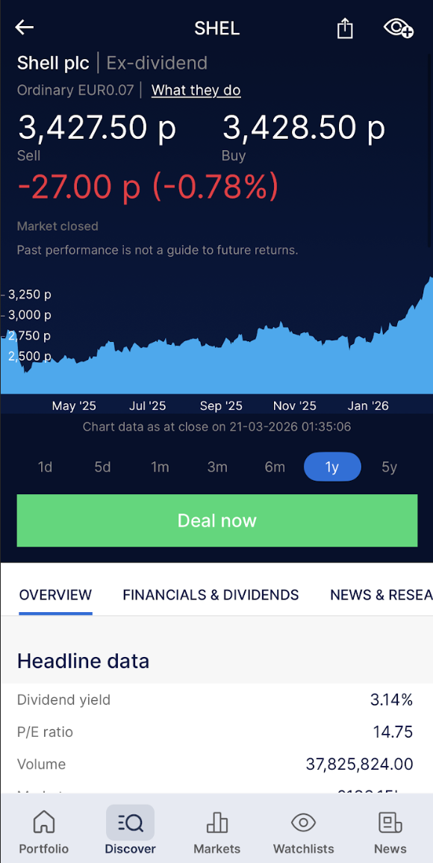
Vanguard Funds Plc
- Line Chart
- Overview
  - Headline Data
  - Performance
  - Reports & Accounts
- Markets
  - Risers/Fallers
  - Currencies
  - Commodities
  - Most traded
- Watchlists
  - Create a watchlist
- News
  - Investment ideas
  - Personal finance
  - Share research and insight
  - Fund research and insight
  - Investment trust research and insight
  - ETF research and insight
  - Newsroom
  - News from ShareCast
Search test – 1 major ETF:
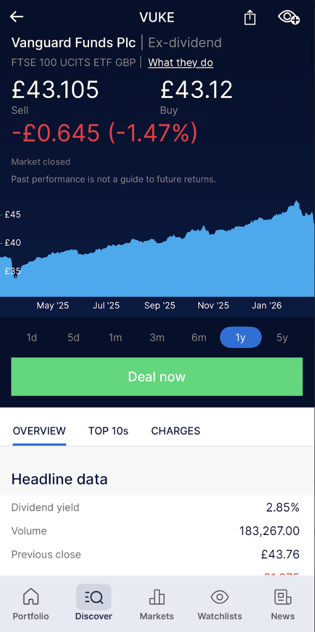
- Line Chart
- Overview
  - Headline data
  - Costs
  - Important documents
  - Basics
  - Value Assessment
- Top 10s
  - Exposures
  - Sectors
  - Countries
- Charges
- How much might it cost?
Autocomplete & results richness (1–5): 1.5
Search results appear structured but lack real depth. While multiple tabs are surfaced (overview, charts, reports, etc.), the underlying data is minimal—particularly for individual equities and ETFs.
There is no meaningful equity research layer (e.g. buy/sell ratings, analyst consensus, or forward-looking insights), and even basic financial metrics are limited. As a result, users cannot conduct substantive analysis within the app and are pushed to external platforms for standard investment information.

4. Trading Workflow (Phase A – 2.4)
4.1 Search & Quotes
Asset classes available (tick): [/] Equities [/] ETFs [/] Mutual funds [/] Bonds [ ] Options [ ] Crypto [ ] FX [/] Other: Investment trusts
Market access (tick): [/] US [/] UK [/] Europe [] Japan [] HK/China A [ ] Local: ______ [ ] Other: ______
4.2 Order Placement
Order types offered (tick): [/] Market [/] Limit [/] Stop [] Stop-limit [ ] Trailing stop [ ] Bracket/OCO [ ] Fractional by $
Taps from quote page to order submission: 4-5
Fee disclosure clarity (1–5): There is a full fee page which is different and more transparent than most.
“Are you sure?” confirmation: [/] Yes [ ] No
Execution speed: [] Instant [/] Acceptable [ ] Slow
Confirmation style (popup/toast/push/email): On screen popup + email confirmation
Timing: Immediate on-screen confirmation email follows shortly after execution
4.3 Order Management
Modify open orders? [/] Yes [ ] No
Cancel orders easily? [/] Yes [ ] No
Order history easy to find? (1–5): 3
Functionality exists but isn’t especially intuitive—order history is accessible, though navigation isn’t as streamlined or prominent as on more modern trading platforms.

5. Portfolio & Account Management (Phase A – 2.5)
5.1 Portfolio Presentation
Visuals used (tick): [] Pie [/] Line charts [ ] Tables only
Shows (tick): [/] Cost basis [/] Realised P/L [/] Unrealised P/L [ ] Time-weighted return [] Currency breakdown
Clarity of portfolio view (1–5): 3
- Notes: Portfolio view is functional but quite basic. Core information (holdings, P/L, valuation) is available, but visualisation is limited and lacks deeper analytics (e.g. performance attribution, currency exposure, or time-weighted returns). The interface prioritises simplicity over insight, which may suit casual investors but feels underpowered for more active users.
5.2 Dividend Management
Dividend view present? [/] Yes [ ] No
DRIP/reinvestment option? [/] Yes [ ] No
Notes: Dividend information is available but fairly basic—users can view payments and history, though insights (e.g. yield tracking or forecasts) are limited. A dividend reinvestment (DRIP) option is offered, but it is not highly visible in the interface and requires manual setup rather than being seamlessly integrated into the portfolio experience.
5.3 Reporting & Tax
Export options: [/] CSV [/] PDF [/] Tax forms (e.g. 1099): UK tax certificates (Consolidated Tax Certificate, Capital Gains reports)
Realised vs unrealised clearly separated? [/] Yes [ ] No
Overall reporting quality (1–5): 3
Reporting is relatively strong compared to other areas—clear and compliant for UK tax purposes—but still lacks advanced customisation and analytical depth (e.g. scenario analysis or more granular breakdowns).

6. Research, Education & Community (Phase A – 2.6)
6.1 Market Research Tools
News feed: [/] Yes [ ] No
- Notes: Basic news feed available (e.g. ShareCast), but limited depth and not well integrated into investment decision-making.
Analyst ratings: [ ] Yes [/] No
Stock screener: [/] Yes [ ] No
- Notes: Screener exists but is relatively simplistic—more geared toward funds than equities, with limited filtering and comparison capabilities.
Earnings calendar: [] Yes [] No
Other tools (fundamentals, ESG, etc.): Very limited—basic fund factsheets and some high-level data, but little in the way of detailed fundamentals, ESG scoring, or advanced analytics.
Paywalled features? [ ] Yes [/] No If yes, which: _________________
6.2 Educational Content
Types: [/] Articles [/] Videos [ ] Quizzes [ ] Courses/Academy
Quality for beginners (1–5): 4
Notes on pacing/structure: Content is clear, well-written, and accessible for beginners, with a strong focus on explaining basic investing concepts and products. However, it is not structured as a progressive learning journey—more a collection of articles and guides than a cohesive curriculum. Limited interactivity and depth for more advanced users.
6.3 Community & Social Trading
Social/copy trading present? [] Yes [/] No
Community quality (toxic/helpful/quiet): NA
Moderation quality (1–5): NA

7. Support & Security (Phase A – 2.7)
7.1 Customer Support
Channels available: [] Live chat [/] Email [/] Phone [ ] Tickets [/] FAQ
Tested channel: FAQ
Response time: NA
Quality (1–5): 2
Notes: FAQ is reasonably comprehensive and easy to access, but answers can be generic and not always tailored to specific user scenarios. Absence of live chat limits quick issue resolution, and users may need to escalate to phone/email for anything beyond basic queries.
7.2 Security Features
Login: [/] Password [/] Biometric [/ ] 2FA (SMS) [ ] 2FA (App)
Notes: Standard security setup—biometric login available on mobile and SMS-based 2FA for added verification. However, no authenticator app support (e.g. Google Authenticator), which feels outdated compared to more security-focused platforms.
Session timeout behaviour: Auto-logout after a period of inactivity; reasonably strict, requiring re-authentication to continue.
Investor protection scheme (e.g. SIPC/FSCS):
FSCS (UK) – protection up to £85,000

8. User Experience Synthesis (Phase A – 2.8)
8.1 Design Aesthetic
Style (modern/minimal/corporate/cluttered): Clean, minimal, but distinctly corporate
Visual appeal (1–5): 3
8.2 Emotional Response
What delighted you? The interface is clean and uncluttered, making basic navigation and portfolio checks straightforward.
What frustrated you? The app feels overly basic and lacks depth—there is minimal data, limited visualisation, and no standout or innovative features. Searching for stocks is unintuitive, with results that prioritise structure over clarity and make it harder than expected to quickly find and evaluate assets. Overall, the experience is functional but unengaging.
8.3 Stand-Out Elements
Unique UX wins:
- Clean, uncluttered interface that keeps core tasks simple
- Strong sense of stability and trust (feels reliable, if not exciting)
Major UX flaws:
- Search is unintuitive and inefficient, making it harder than expected to find and compare assets
- Very limited data and lack of embedded research or insights
- No innovative or standout features—nothing that differentiates the experience
- Feels more like an account dashboard than a fully functional investing platform
- Lack of modern UX elements (e.g. smart discovery, personalisation, or interactive tools)

9. AI Features & Stand-Outs (Phase C)
9.1 AI Features Present (tick)
[] Robo-advisory portfolios [ ] Predictive analytics [ ] Personalised recommendations
[] Summarised earnings/reports [] AI chatbot assistant [ ] AI compliance/risk checks
Notes per feature:
- Robo-advisory portfolios: NA
- Predictive analytics: NA
- Personalised recommendations: NA
- Summarised earning/reports: NA
- AI chatbot assistant: NA
- AI compliance/risk checks: NA
9.2 Chatbots & Virtual Assistants
Entry point: NA
Prompt comprehension (1–5): NA
Accuracy (1–5): NA
Escalation to human: [ ] Smooth [] Clunky [/] Not available
Notes: No chatbot or virtual assistant is available within the app or support flow. All support is handled through traditional channels (FAQ, phone, email), with no conversational or AI-driven interface.
9.3 Personalisation
Personalises: [ ] Education [] News [/] Alerts [] Product suggestions
Quality of match to behaviour: 2
Personalisation is very limited. Alerts can be set, but they are manual and rule-based (e.g. price alerts) rather than behaviour-driven or intelligent. There is no meaningful tailoring of content, news, or product recommendations based on user activity or portfolio.
9.4 Compliance & Risk Management
Visible AI-driven risk/AML/suitability nudges? No
9.5 Transparency & Ethics
Explains how AI works? [ ] Yes [/] No
Can user opt out of AI? [ ] Yes [/] No

